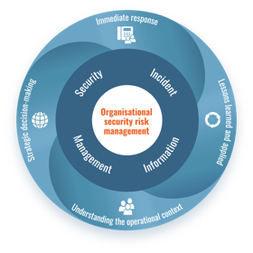
Security Incident Information Management

Incident Alert Template

Key information to include within an incident alert:
- 3Ws - When, Where, and What happened
- Incident category
- Reference number
- Added value - provide comments, analysis or advice, where appropriate.

Include disclaimer here explaining the nature of the information, who it is intended for, and how it should be utilised.
Incident Alert Template
Incident category

Location

Date

Information

Comment

Reference #
Emphasise here the importance and purpose of security incident reporting and information sharing either within your organisation, or within the interagency network.

This document is published by Insecurity Insight. It is made possible by the generous support of the American people through the United States Agency for International Development (USAID). The contents are the responsibility of Insecurity Insight and
do not necessarily reflect the views of USAID or the U.S. Government.




Insecurity Insight. Email info@insecurityinsight.org

